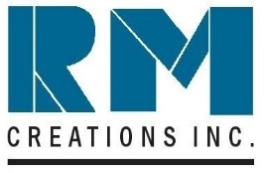
R.M. CREATIONS INC.
50 CRAGWOOD ROAD, SUITE 308, SOUTH PLAINFIELD, NJ – 07080
TEL: 908-222-1500 FAX: 908-222-1665

January 11, 2022

RM GREEN INITIATIVE

RM Creations, Inc. strives to have a sustainable green foot print and is continuously seeking ways to achieve the same.

RM sales are mainly in stainless steel, a highly sustainable product. It is one of the main components used in bridges, street signs, buildings and other infrastructure projects. The stainless use allows sustainability of these projects for decades, while also reducing the required additional resources to maintain them.

Aluminum is another item that RM sells. Aluminum is mendable, light weight, and strong. This allows less product to be used, while preserving a product’s intended use. Less resources are used accordingly. One example is airplanes, which are made with aluminum and have less carbon emissions due to more aerodynamics and overall lower weight.

RM seeks to buy from companies that are mindful of reducing their carbon foot print when producing stainless steel and aluminum. In order to promote sustainability and lower carbon foot print, RM encourages its customers to buy products that are made in an environmentally friendly way.

Hazardous material is harmful to the environment and reduces long term sustainability, therefore, RM avoids any products made from hazardous material.

RM understands that all material sold, can’t be used completely. There will be run offs and pieces that are scrap. RM tries to take all scrap produced and recycle it. Scrap generated is often used by companies that produce the stainless and aluminum that RM buys. This helps close the recycling cycle.

Best regards,

Mukesh Desai President
RM Creations, Inc.

